LangChain Components
https://www.youtube.com/watch?v=-xSJA8-o6Eg&list=PLKnIA16_RmvaTbihpo4MtzVm4XOQa0ER0&index=4
00:00 – Intro
02:15 – Recap
04:48 - LangChain Components
05:46 – Models
16:47 – Prompts
24:20 – Chains
31:55 – Indexes
39:10 – Memory
44:04 – Agents
1. Introduction: Why This Video Exists
This video is designed to give a conceptual roadmap of LangChain, not hands-on coding.
Key Intent
- Understand how LangChain is organized internally
- Understand the thinking process of the library designers
- Build a mental model before writing any code
👉 Industry reality:
Teams that rush to code without understanding architecture struggle later with:
- Scaling
- Model switching
- Cost optimization
- Maintenance

2. Recap of Previous Video (Context Setting)
From the first video, we established:
What LangChain Is
- An open-source framework for building LLM-powered applications
Why LangChain Is Needed
A real-world GenAI system (e.g., “Chat with PDF”) involves:
- Document loading
- Text splitting
- Embeddings
- Vector databases
- Retrieval
- LLM interaction
Building this from scratch means:
- Many components
- Complex interactions
- Large amount of glue code
What LangChain Solves
- Orchestration of components
- Pipeline creation using chains
- Minimal code for complex workflows
- Model-agnostic development
Common Industry Use Cases (from Video 1)
- Conversational chatbots
- AI knowledge assistants
- AI agents
This sets the stage for understanding LangChain components.

3. LangChain Components: The Big Picture
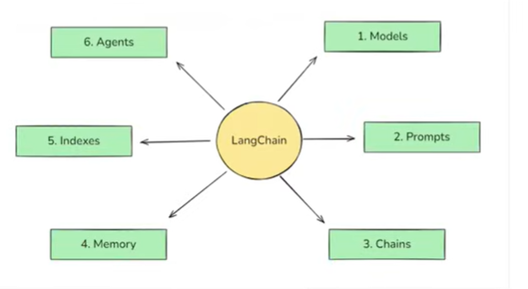
LangChain is built around six core components:
- Models
- Prompts
- Chains
- Memory
- Indexes
- Agents
If you understand these six, you understand 80–90% of LangChain.
This video starts with the most important component: Models.

4. Models Component (Most Critical Component)
4.1 Why Models Became a Problem
Historically, NLP had two major challenges:
- Understanding user intent (NLU)
- Generating context-aware responses
Large Language Models (LLMs) solved both simultaneously.
New Problem Introduced by LLMs
- LLMs are huge (often 100GB+)
- Cannot be run locally by individuals or small companies
- Cloud hosting is extremely expensive
Solution: APIs
Companies like:
- OpenAI
- Anthropic
- Google
- AWS
Expose LLMs via APIs, allowing:
- Pay-per-use
- No infrastructure management

4.2 The Real Problem: API Fragmentation
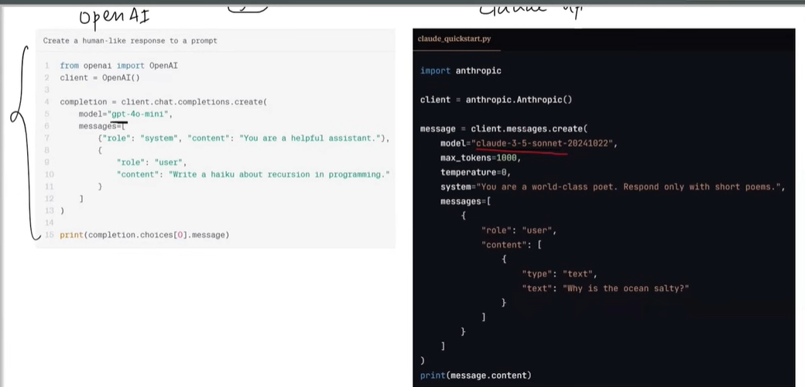
Each provider has:
- Different API formats
- Different request/response structures
- Different SDKs
Result
- Switching models = rewriting code
- Using multiple models = messy codebase
- Hard to optimize for cost or performance

4.3 What LangChain’s Models Component Does
LangChain introduces a standardized interface.
Core Idea
“Write your business logic once. Swap models with minimal code changes.”
With LangChain:
- Calling OpenAI or Anthropic looks almost identical
- Output formats are standardized
- Parsing responses becomes easier
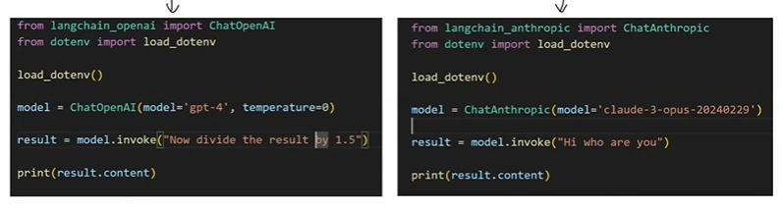
Why This Matters in Industry
- Companies frequently switch models due to:
  - Cost
  - Latency
  - Policy changes
- Vendor lock-in is risky
- LangChain reduces migration effort drastically

4.4 Types of Models in LangChain
1. Language Models - LLMS
- Text input → Text output
- Used for:
  - Chatbots
  - Agents
  - Summarization
  - Reasoning tasks
2. Embedding Models
- Text input → Vector output
- Used for:
  - Semantic search
  - Document retrieval
  - Similarity matching
LangChain supports both, making it suitable for full GenAI pipelines.

Industry Perspective (Models – Where It’s Necessary)
In real companies:
- OpenAI might be used for reasoning
- Smaller open-source models for cheaper tasks
- Local models for privacy-sensitive data
LangChain enables hybrid model strategies, which is a huge industry advantage.

Project Ideas (Models – Only Where Relevant)
Project 1: Model Switching Demo
- Same application
- Switch between OpenAI and Anthropic
- Compare:
  - Cost
  - Response quality
  - Latency
Purpose: Understand model-agnostic architecture

5. Prompts Component
5.1 What Is a Prompt?
A prompt is simply:
The input you send to an LLM
But small changes in prompts can cause big differences in output.

5.2 Why Prompts Are Extremely Important
LLMs are highly sensitive to:
- Tone
- Role
- Structure
- Examples
This led to the emergence of:
- Prompt Engineering as a skill
- Dedicated prompt-handling systems
LangChain formalizes this via the Prompts component.

5.3 Types of Prompts Supported by LangChain
1. Dynamic & Reusable Prompts
- Use placeholders
- Fill values at runtime
- Same prompt works for many users
Example use:
- “Summarize {topic} in {tone}”
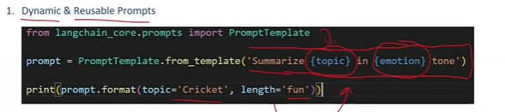

2. Role-Based Prompts
- System-level instruction
- User-level input
Used to guide the persona of the model:
- Doctor
- Engineer
- Teacher
- Customer support agent
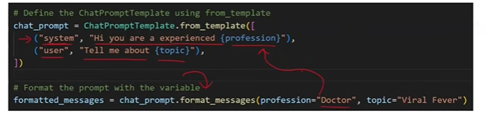

3. Few-Shot Prompts
- Provide examples before asking the real question
- Helps LLM learn patterns
Common in:
- Classification
- Tagging
- Ticket routing
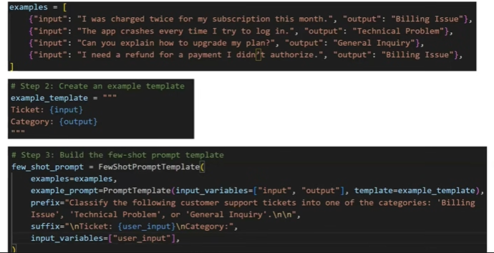
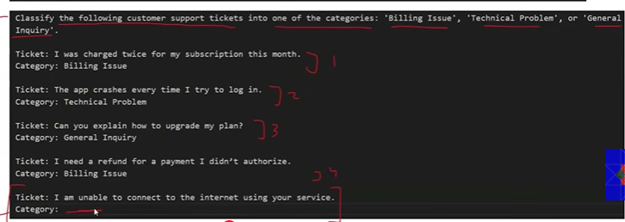

6. Chains (Why LangChain Is Called “LangChain”)
Chains are the most important component of LangChain — so important that the framework itself is named after them.
6.1 What Are Chains?
A Chain is a way to build an LLM application as a pipeline.
In simple words:
Chains allow you to connect multiple steps of an LLM workflow so that
the output of one step automatically becomes the input of the next step.
You do not have to manually pass outputs between steps.

6.2 Why Chains Are Needed
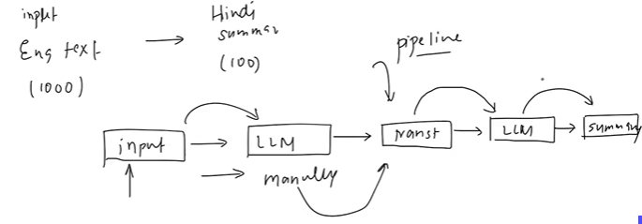
Without chains:
- You manually call LLM 1
- Capture its output
- Pass that output to LLM 2
- Repeat this for every stage
This leads to:
- Boilerplate code
- Bugs
- Poor readability
- Hard-to-maintain systems
Chains solve this by doing the heavy lifting behind the scenes.

6.3 Sequential Chains (Basic Pipeline)
Example Explained in the Transcript
Goal:
Build an LLM application where:
- Input: Large English text (~1000 words)
- Output: Hindi summary in less than 100 words
Pipeline Design
- User provides English text
- LLM 1 translates English → Hindi
- LLM 2 summarizes Hindi text
- Final summary is returned to the user
Using Chains:
- You define this flow once
- Call the chain with input text
- Everything executes automatically
You don’t care about intermediate outputs anymore.

Industry Perspective (Chains – Where It Truly Matters)
In real companies:
- AI workflows are never single-step
- They involve:
  - Cleaning input
  - Translating
  - Summarizing
  - Validating
  - Formatting output
Chains allow companies to:
- Build clean AI pipelines
- Debug each stage independently
- Scale workflows easily
This is why LangChain is used in production systems, not just demos.

Project Idea (Chains – Necessary Here)
Project: Multi-Stage Content Processor
- Input: Blog/article
- Stage 1: Language detection
- Stage 2: Translation (if needed)
- Stage 3: Summary
- Stage 4: Key takeaways generation
This teaches pipeline thinking, which is critical in industry.

6.4 Parallel Chains (Running Things Simultaneously)
Chains are not limited to linear pipelines.
Parallel Chain Concept
You can:
- Send the same input to multiple LLMs at the same time
- Combine their outputs later
Example from Transcript
Goal: Generate a detailed report on a topic (e.g., “911 Incident”)
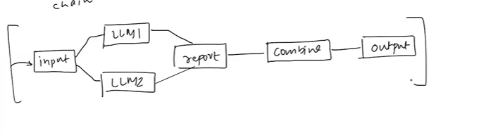
Pipeline:
- LLM 1 generates report
- LLM 2 generates report (different style / source)
- LLM 3 combines both reports into one final response
All of this runs in parallel.

Industry Perspective (Parallel Chains)
Used heavily in:
- Research tools
- News aggregation
- Financial analysis
- Risk assessment
Why?
- Reduces bias
- Improves coverage
- Produces higher-quality outputs

Project Idea (Parallel Chains – Optional but Valuable)
Project: Multi-Perspective Report Generator
- Input: Topic
- Parallel outputs:
  - Technical explanation
  - Business impact
  - Risks
- Final LLM merges everything

6.5 Conditional Chains (Decision-Based Pipelines)
Chains can also behave based on conditions.
Example from Transcript
Use case: Feedback processing system
Flow:
- User submits feedback
- LLM analyzes sentiment
- If feedback is positive → Send “Thank You”
- If feedback is negative → Notify customer support via email
This is decision-based AI, not just text generation.
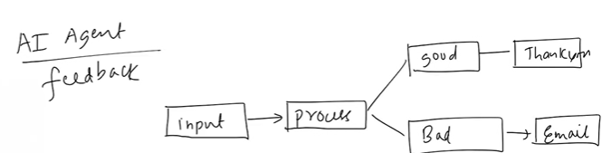

Industry Perspective (Conditional Chains)
Very common in:
- Customer support automation
- HR screening
- Complaint management
- Moderation systems
This is where GenAI meets real business logic.

Project Idea (Conditional Chains – Highly Practical)
Project: AI Feedback Router
- Input: User feedback
- Output:
  - Auto-reply for positive feedback
  - Ticket creation for negative feedback

7. Indexes (Connecting LLMs to External Knowledge)
Indexes solve one of the biggest limitations of LLMs.
Indexes connect your applications to exteranal knowledge – such as pdfs, websites or databses
7.1 The Core Problem
LLMs like ChatGPT:
- Know public internet data
- Do NOT know:
  - Company policies
  - Private documents
  - Internal databases
So questions like:
- “What is my company’s leave policy?”
- “What is our notice period?”
Cannot be answered by default.

7.2 What Are Indexes?
Indexes allow you to:
Connect your LLM application to external knowledge sources
like PDFs, websites, or databases.

7.3 Components of Indexes
Indexes are built using four components:
- Document Loader
Loads data from PDFs, websites, Google Drive, databases, etc.
- Text Splitter
Breaks large documents into smaller chunks.
- Vector Store
Stores embeddings (vectors) of document chunks.
- Retriever
Finds the most relevant chunks for a user query.
Together, these enable semantic search + LLM reasoning.

7.4 How the Indexing Pipeline Works (End-to-End) – Same PDF loader example we seen previosuly
- Load document (e.g., company rulebook PDF)
- Split into chunks (pages / paragraphs)
- Convert chunks into embeddings
- Store embeddings in vector database
- User asks a question convert that to embedding
- Using the embedding generated from user query - Retriever finds relevant chunks from the vector database
- LLM generates an answer using those chunks
This entire workflow is abstracted by Indexes in LangChain.

Industry Perspective (Indexes – Extremely Important)
These powers:
- “Chat with PDF”
- Internal company chatbots
- Legal document analysis
- Healthcare record assistants
Most enterprise GenAI apps = Indexes + LLM.

Project Idea (Indexes – Mandatory Learning Project)
Project: Company Policy Assistant
- Upload HR policy PDFs
- Ask natural language questions
- Get accurate, source-based answers
This is one of the most demanded GenAI projects in industry.

8. Memory (Making Conversations Stateful)
8.1 The Problem: Stateless LLM APIs
LLM APIs call are stateless.
This means:
- Every API call is independent
- The model forgets previous interactions
Example:
- Q1: “Who is Narendra Modi?”
- Q2: “How old is he?”
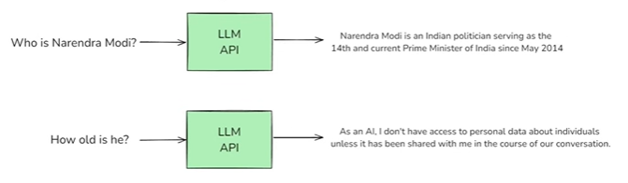
The model fails unless context is re-provided.

8.2 Why This Is a Big Problem
Without memory:
- Chatbots feel dumb
- Conversations feel broken
- User experience is frustrating

8.3 What Memory Does in LangChain
Memory allows you to:
Store conversation context and send it back with each LLM call.
This makes:
- Conversations natural
- Follow-up questions possible
- Chatbots usable

8.4 Types of Memory in LangChain
1. Conversation Buffer Memory
- Stores entire chat history
- Simple but expensive for long chats
- Whatever conversation we had we will store all of it and next time when we are querying we will send the entire history of the conversation whatever we stored to llm
2. Conversation Buffer Window Memory
- Stores last N interactions
- Balances cost and context
- Ex: Storing last 100 conversations
3. Summary-Based Memory
- Stores summarized conversation
- Saves tokens and money
4. Custom Memory
- Stores specific user facts
- Preferences, settings, personal data

Industry Perspective (Memory)
Used in:
- Customer support bots
- Personal AI assistants
- Therapy and coaching bots
- Sales assistants
Memory directly impacts cost, UX, and scalability.

Project Idea (Memory – Highly Practical)
Project: Context-Aware Chatbot
- Remembers user preferences
- Handles long conversations efficiently
- Uses summary-based memory

9. Agents (The Most Advanced Component)
Agents are the final and most powerful component.
9.1 Chatbot vs AI Agent
Chatbot | AI Agent
Talks | Talks + Acts
No tools | Uses tools
No reasoning | Has reasoning
An AI Agent is:
A chatbot with superpowers

9.2 What Makes an AI Agent Special?
AI Agents have:
- Reasoning capability
- Access to tools (APIs, calculators, databases)
Example
Consider a chatbot on a travel website:
- A user asks the chatbot:
“What are the best places to visit during summer?”
→ The AI agent reasons and suggests suitable destinations.
- Then the user asks:
“Book my travel for one of these places.”
→ The AI agent uses tools (booking APIs, payment systems, databases) to complete the booking.

9.3 Example Explained
Travel chatbot:
- Chatbot → Suggests destinations
- AI Agent →
  - Finds cheapest flights
  - Calls APIs
  - Books tickets
This is action-oriented AI.

9.4 How AI Agents Work (Core Idea)
- Understand user query
- Break it into steps (reasoning)
- Decide which tool to use
- Call the tool
- Use output
- Repeat until task is complete
This is often powered by chain-of-thought reasoning.
Example 2
An AI agent has access to tools such as a calculator and a weather API.
User Query:
“Can you multiply today’s Delhi temperature by 3?”
Explanation:
- The AI agent first uses the weather tool to fetch today’s temperature in Delhi.
- Then, it uses the calculator tool to multiply the retrieved temperature by 3.
- Finally, it provides the calculated result to the user.
This example shows how an AI agent combines reasoning with multiple tools to answer a single query.

Industry Perspective (Agents – Very Important)
Companies are investing heavily in:
- AI assistants
- Workflow automation
- Autonomous systems
Agents are expected to be the next big wave in GenAI.

Project Idea (Agents – Advanced but High Value)
Project: AI Travel Agent
- Finds flights
- Checks weather
- Calculates costs
- Books tickets (mock APIs)
This single project can differentiate your profile strongly.

Why Chains are the backbone
How Indexes connect private data
Why Memory is essential for UX
Why Agents represent the future

